Maestro Reservation Daily Routine

Run these 2 reports daily
Maestro Reservation Error (once/day in low season; twice/day in high season – morning and afternoon)
Reservation Log – Name List (in the afternoon)

Maestro Reservation Error
- Go to On-Request report and select Maestro Reservation Error Report
- Populate the following fields to generate the report
Begin Date/Time: Date and time of the last report run
End Date/Time: Current date + 23:59
Error Level: All Error Levels
Error Type: System and User

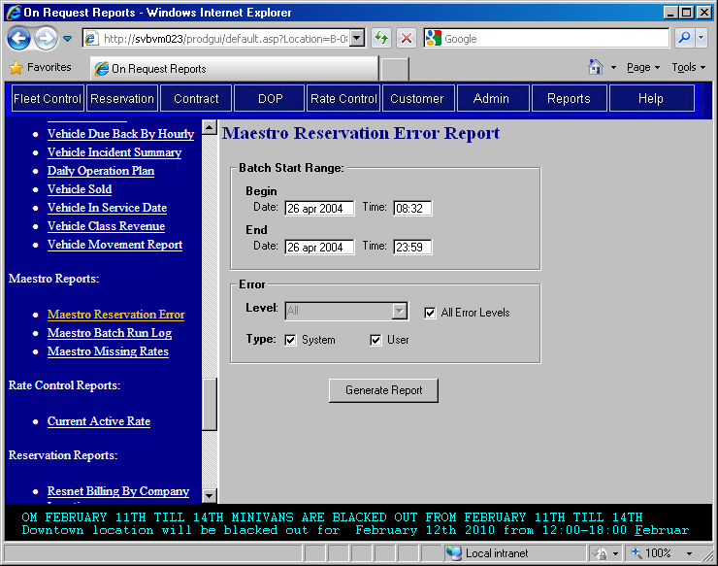

- After generating the report, print it.

- Check the following in the report
- Transaction time is up-to-date without any missing date
- Batch is in sequence with no missing batch
- If the Error Level is Error, it means the new information is not updated in the system.
- Rate-related error messages indicate that there may be some problems with the rate delivered.
- Occasionally, pay attention to Warning messages.

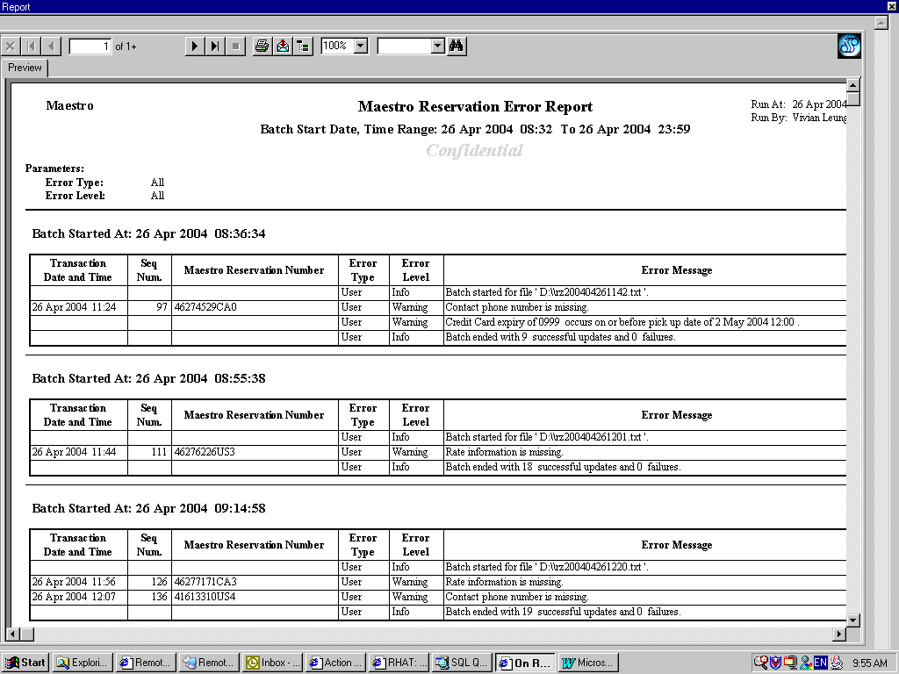

Reservation Log – Name List
- Go to On-Request report and run the Reservation Log – Name List report
- Use the following parameters:
Source: Maestro
Vehicle Type: All
Vehicle Class: All
Company: a/BRAC of BC Ltd.
Pick up Location: All
Pick up Date Start: Date of next day
Pick up Date End: Date of next day (If current day is Friday, use next Monday’s date)
Include No Show: No
Sort by: Pick up time

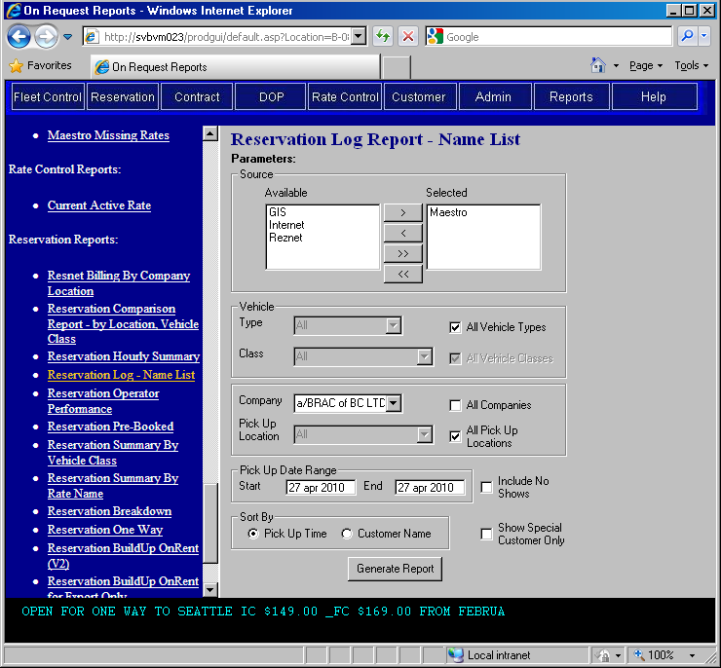

- Print report and check the followings:
- Reservations with no rates
- Rate amounts and vehicle class
- Rate code, may happen to have unexpected rate code delivered to us.
- Pick up location (especially the seasonal pick up locations)

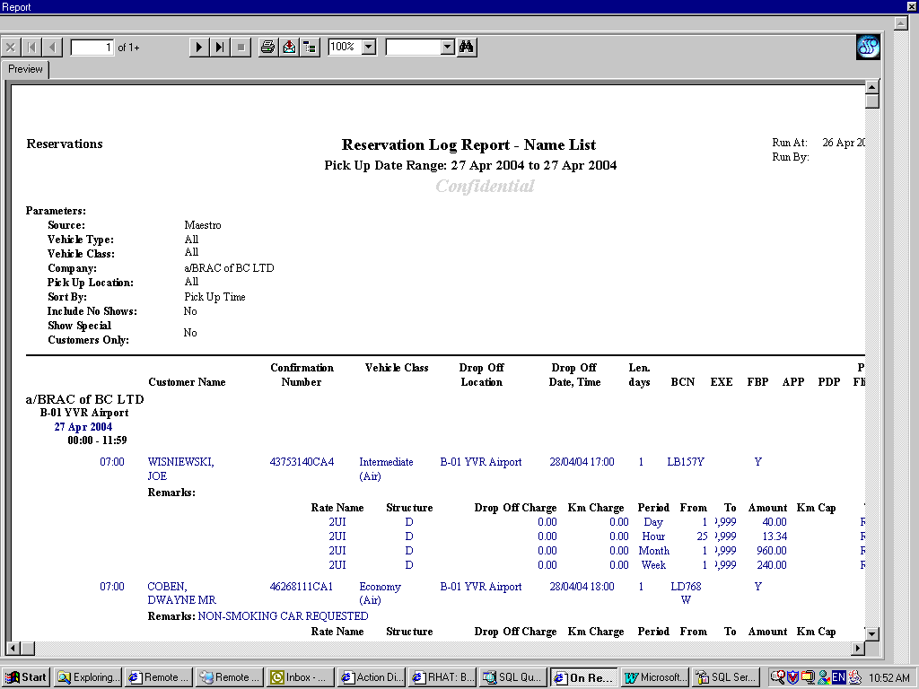

- For missing rates, check the reservation in GIS first. You can check all reservations with missing rates via the Maestro Missing Rates report. If the rate is missing in a reservation, log on to Maestro to retrieve the reservation and assign the corresponding GIS rate.

Problems and Solutions

Here are some problems you may encounter with Maestro reservations.
- Transaction date/time is not up-to-date

- Check Maestro loader, reservations may not be pulled for a while.

- Transaction date/time or batch is missing

- Log on to Maestro and go to the B520 screen. Type in:
Command: PUL
Routing code: YVR91
Transaction Date: Date of the transaction
Starting Sequence:
Ending Sequence:

- Missing rate in reservation

- Log on to Maestro and go to the B502 screen. Type in:
qr or dr at the left-handed top corner
r/res_num in the NAM field
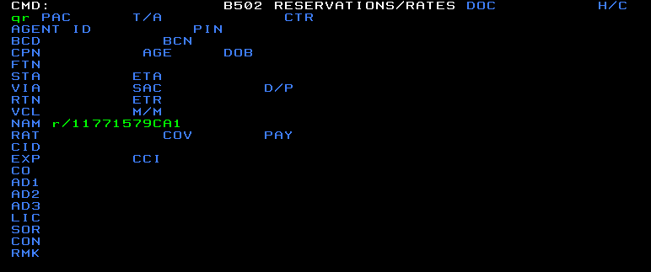

- Look for the rate amount and enter the corresponding GIS rate to reservation.
  - If no rate is quoted in Maestro, use the current GIS rack rate.
  - If tour rate is quoted in Maestro, look at the BCD# or the rate code to get the correct GIS tour rate.

- Error Level = Error in Maestro Reservation Error report and reservation info is not updated

- Look at the error message to find the problems (e.g. no matching data structure; no matching vehicle class code etc) and resolve accordingly. Contact IT department for additional assistance.

- Reservations not delivered (usually happens when corporate upgrades the system)

- Contact Steven Roemerman at (918)624-4088 or steven.roemerman@avisbudget.com to resend missing reservations → need to provide him with the missing reservation’s confirmation #

or

- Call Becky Peachey at (918)624-4121 and ask her to send batches of missing reservations → only need to tell her which specific block of reservations (i.e. from when to when) and for which company

or

- Log on to Maestro and go to the B502 screen
- Retrieve a missing reservation (See Problem #3 above) and press page up to check the time reservation was made
- In GIS, run the Maestro Reservation Error report in the Reports/On-Request screen
- Use the following parameters:
Batch Start Begin Date/Time: With reference to the creation time of missing res
Batch Start End Date/Time: With reference to the creation time of missing res
Error Level: All Error Levels
Type: System and User
- After the report is generated, check the Seq Num. of each transaction and make sure there are no gaps in between Seq. Num.
(Note: Seq. Num is incremental by 1 for each transaction and is reset back to 1 if the transaction falls on a different day than the previous transaction)
- Go through the entire report and take note of all missing sequence numbers
- Log on to Maestro and go to the B520 screen. Type in:
Command: XMT
Routing code: YVR91
Transaction Date: Date of the transaction (same date as your Batch Start date)
Starting Sequence: Missing Seq Num. of your reservation
Ending Sequence: Missing Seq Num. of your reservation

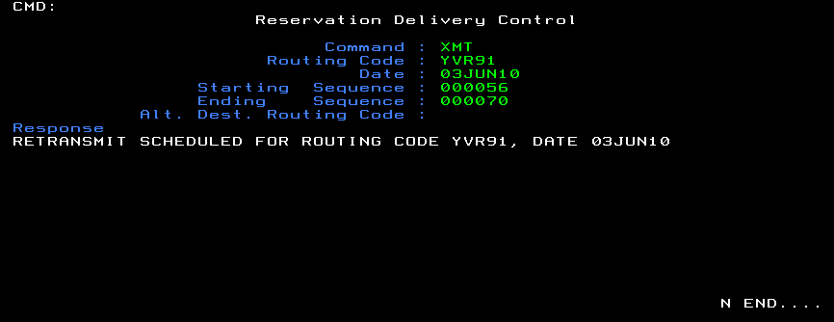

- Check that the reservation exists in GIS (It may take a few minutes for the reservation to be re-delivered)

Revision History

Name | Description | Date
Vivian Leung | Original draft | Apr 30, 2004
Winnie Lei | Updated screenshots and “Problems and Solutions” section | Jun 11, 2010

